HILLY FIELDS FOOTBALL CLUB
SEASON 27: 1993-94
Beckenham Hospital Veterans Cup
P W D L F A
1 0 0 1 2 7
Friendly 30 11 6 13 66 76
TOTAL 31 11 6 14 68 83
Apps Gls Apps Gls
Irving Bartlett 4 1 Kevin Marchant 6 0
Adrian Bennett 21 0 Ray Marchant 13 2
Jason Bennett 1 1 Kevin McCormick 6 0
Alan Collihole 6 3 John Macrea 2 0
Mark Cooper 15 3 Steve Morton 20 7
Brent Dyke 4 0 Colin Palmer 6 0
Stuart Dyke 2 1 Derrick Pankhurst 18 0
Terry Dyke 24 0 Richard Patterson 19 9
Steve Edwards 3 0 Steve Quinn 20 2
Ivor Felton 1 0 Steve Sams 1 0
John Felton 19 0 Charlie Shoppee 1 0
Steve Ford 1 0 Ralph Stanton 4 0
Keith Foster 27 4 Albert St Clair 21 11
Len Franklin 7 0 Dickie Stone 1 0
Phil Hortin 11 0 Mick Spicknell 5 0
Mike Jefferys 7 0 Mario Vaz 14 4
Howard Jones 6 6 Dave Wright 21 3
Mark Kellaway 7 7 Chris Yusuf 1 0
John Kennedy 8 2 OG 2
Mike Lane 12 0
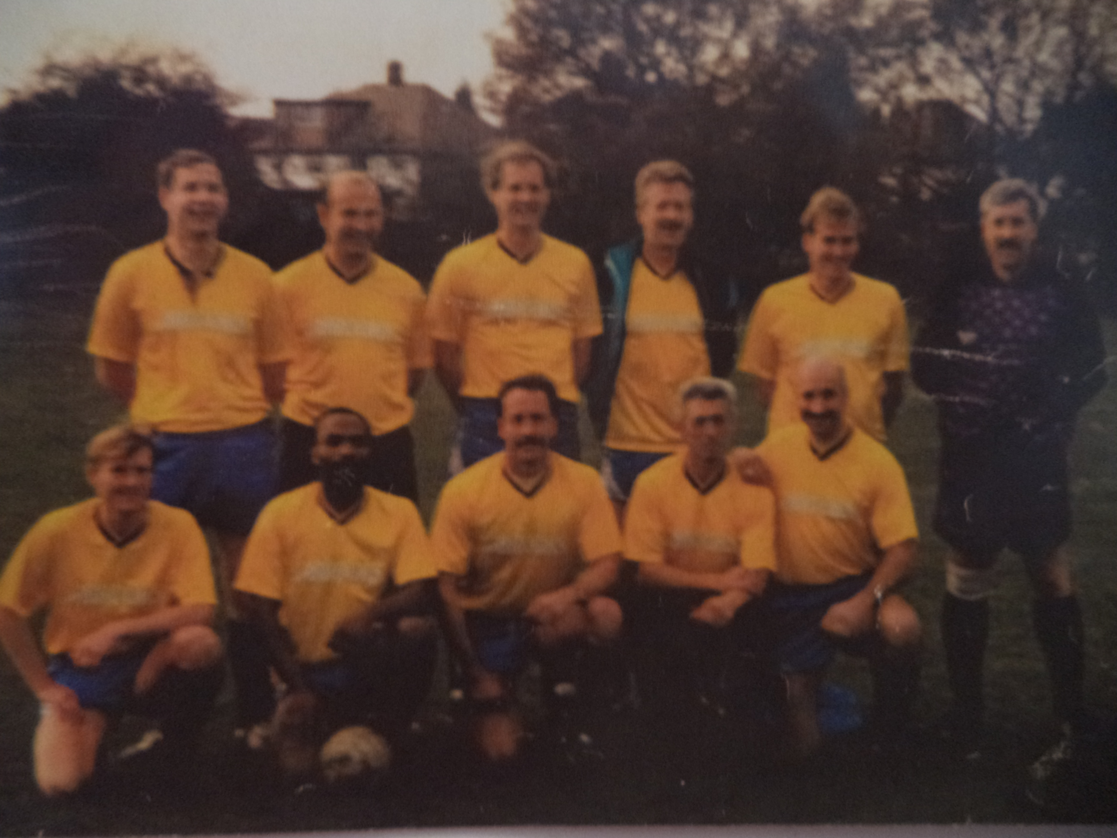
L-R Back: Keith Foster, Adrian Bennett, Richard Patterson, Mark Cooper, Alan Collihole, Terry Dyke
L-R Front: Mike Jefferys, Albert St Clair, Steve Morton, Dave Wright, Mike Lane

